Appendix III
Employer Forms

Feel free to use these forms as templates for your company’s own custom forms. Not all of the forms included in this book will be useful to every business. A few alterations might make the forms work even better. However, be mindful not to add questions that expose the company to discrimination claims.
Not all positions within a company perform the same function. Rather, one company may have a varied work force, ranging from drivers to clerks to professionals. As such, one generic application for all positions is typically insufficient and is not recommended. Employers should consider using applications that are tailored to individual positions or “job families.” The extra effort and minor expense of producing tailor-made applications is more than offset by the long-range savings of time and getting only the specific information you need.

All forms used in this book are freely available for use. You can download them from www.brbpub.com/forms.htm.

Name of Form | Page Number In Lesson | Page Number In Appendix
Applicant/Resume Evaluation | 39 & 125 | 271
Applicant Waiver | 33 | 272
Basic Application, page 1 | 25 | 273
Basic Application, page 2 | 25 | 274
Basic Application, page 3 | 25 | 275
Confidentiality Agreement | 135 | 276
Criminal Background Check Release | 36 | 277
Employee Data Sheet | 131 | 278
Employment Eligibility Verification (I-9) | 32 | 279
Exit Interview Report, page 1 | 211 | 280
Exit Interview Report, page 2 | 211 | 281
General Release Form | 34 | 282
Induction Form | 133 | 283
Local Police Information Request | 79 | 284
Military Records Request, front | 87 | 285
Military Records Request, reverse | 88 | 286
New Employee Record Chart | 132 | 287
New Hire Reporting Form | 147 | 288
Non-Compete Agreement | 136 | 289
Performance Review, page 1 | 177 | 290
Performance Review, page 2 | 178 | 291
Pre-Employment Check by Phone | 68 | 292
Rejection Letter Sample | 141 | 293
Request For Education Verification | 82 | 294
Request For Information | 70 | 295
Substance Abuse Screening Test Consent | 222 | 296
Workers’ Compensation Release | 224 | 297

Applicant/Resume Evaluation

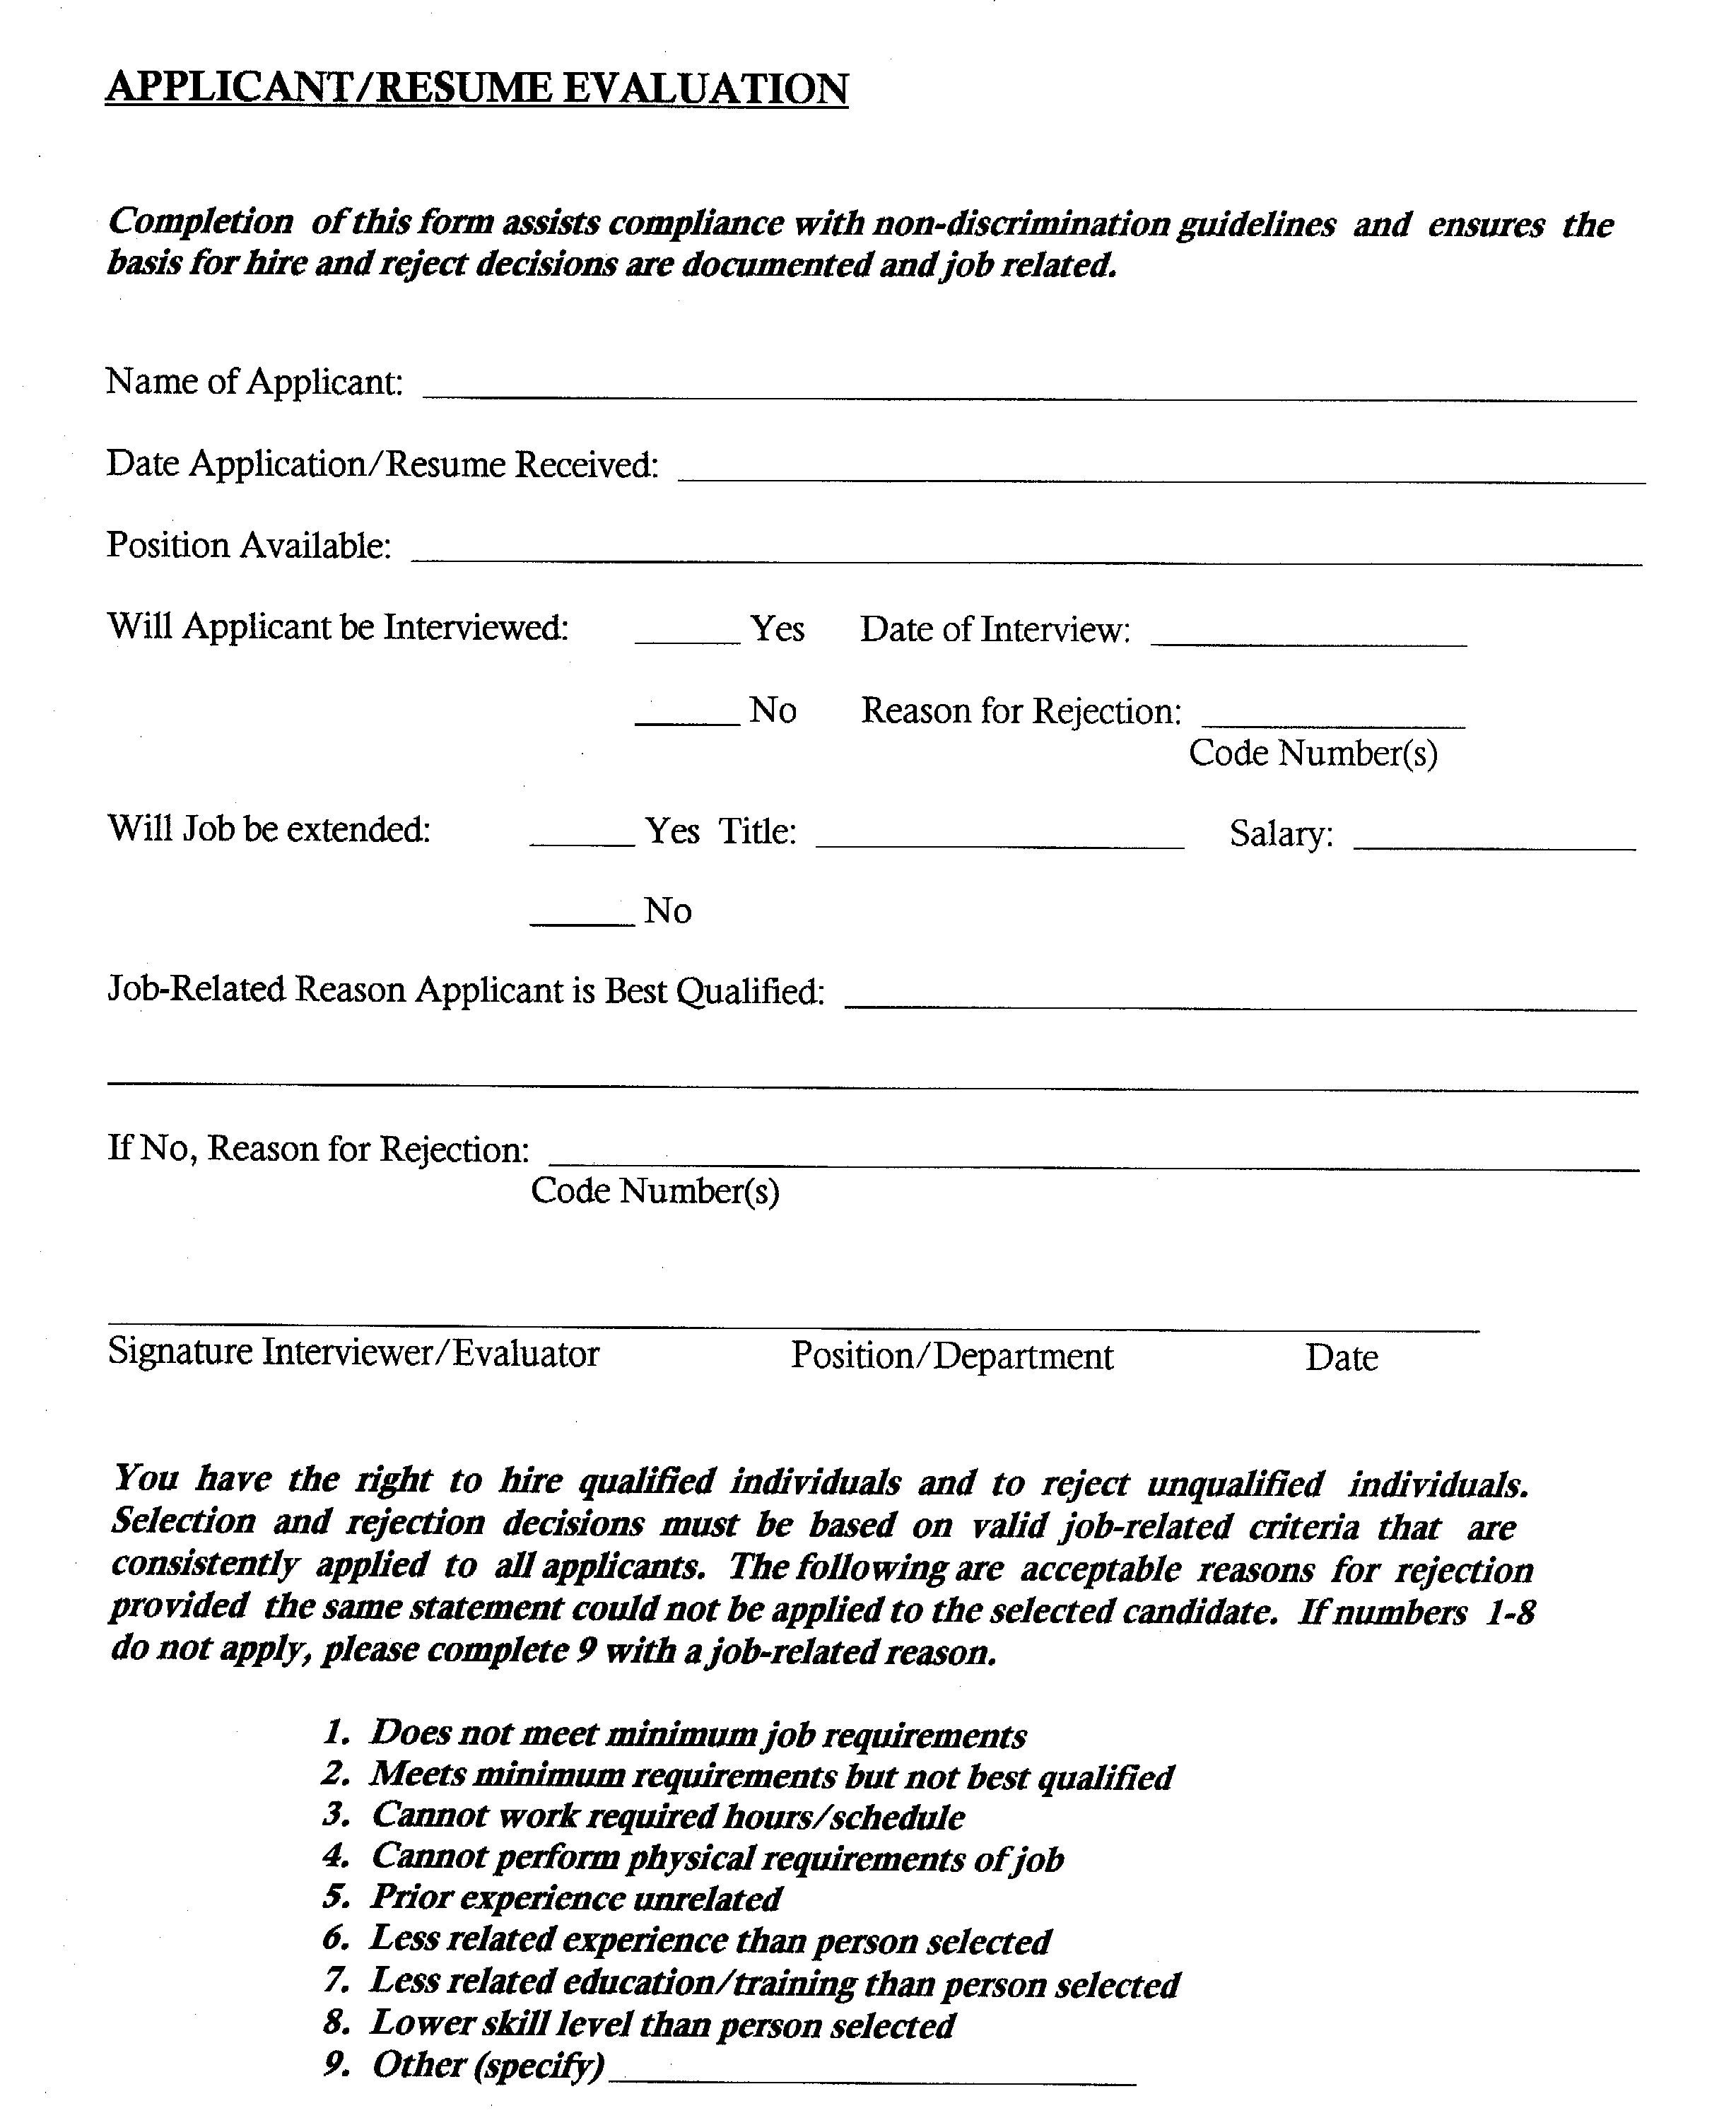

Applicant Waiver

Applicant Waiver Form

(To be signed by all job applicants along with application form.)

- I agree and understand that all the information and statements on my application are correct and no attempt has been made to conceal or withhold pertinent information. I agree that any omission, falsification, or misrepresentation is cause for my immediate termination at any time during my employment.
- In connection with this request, I authorize all corporations, companies, credit agencies, persons, educational institutions, law enforcement agencies and former employers to release information they may have about me, and release them from any liability and responsibility from doing so; further, I authorize the procurement of an investigative consumer report and understand that such report may contain information as to my background, mode of living, character and personal reputation. This authorization, in original and copy form, shall be valid for this and any future reports that may be requested. Further information may be made available upon written request from _____________________________________________.
- I hereby authorize investigation of all statements at this time with no liability arising therefrom.

__________________________________________ _________________________
Signature Date

__________________________________________ _________________________ Signature of Company Representative Date

* * *

STATE of: _________________ This Instrument was acknowledged before me

COUNTY of: _______________ this _____ day of ________________, 20____,

My commission will expire: by ______________________ AS WITTNESS.
______________________

______________________________________
Notary Public No.

Basic Application (page 1)
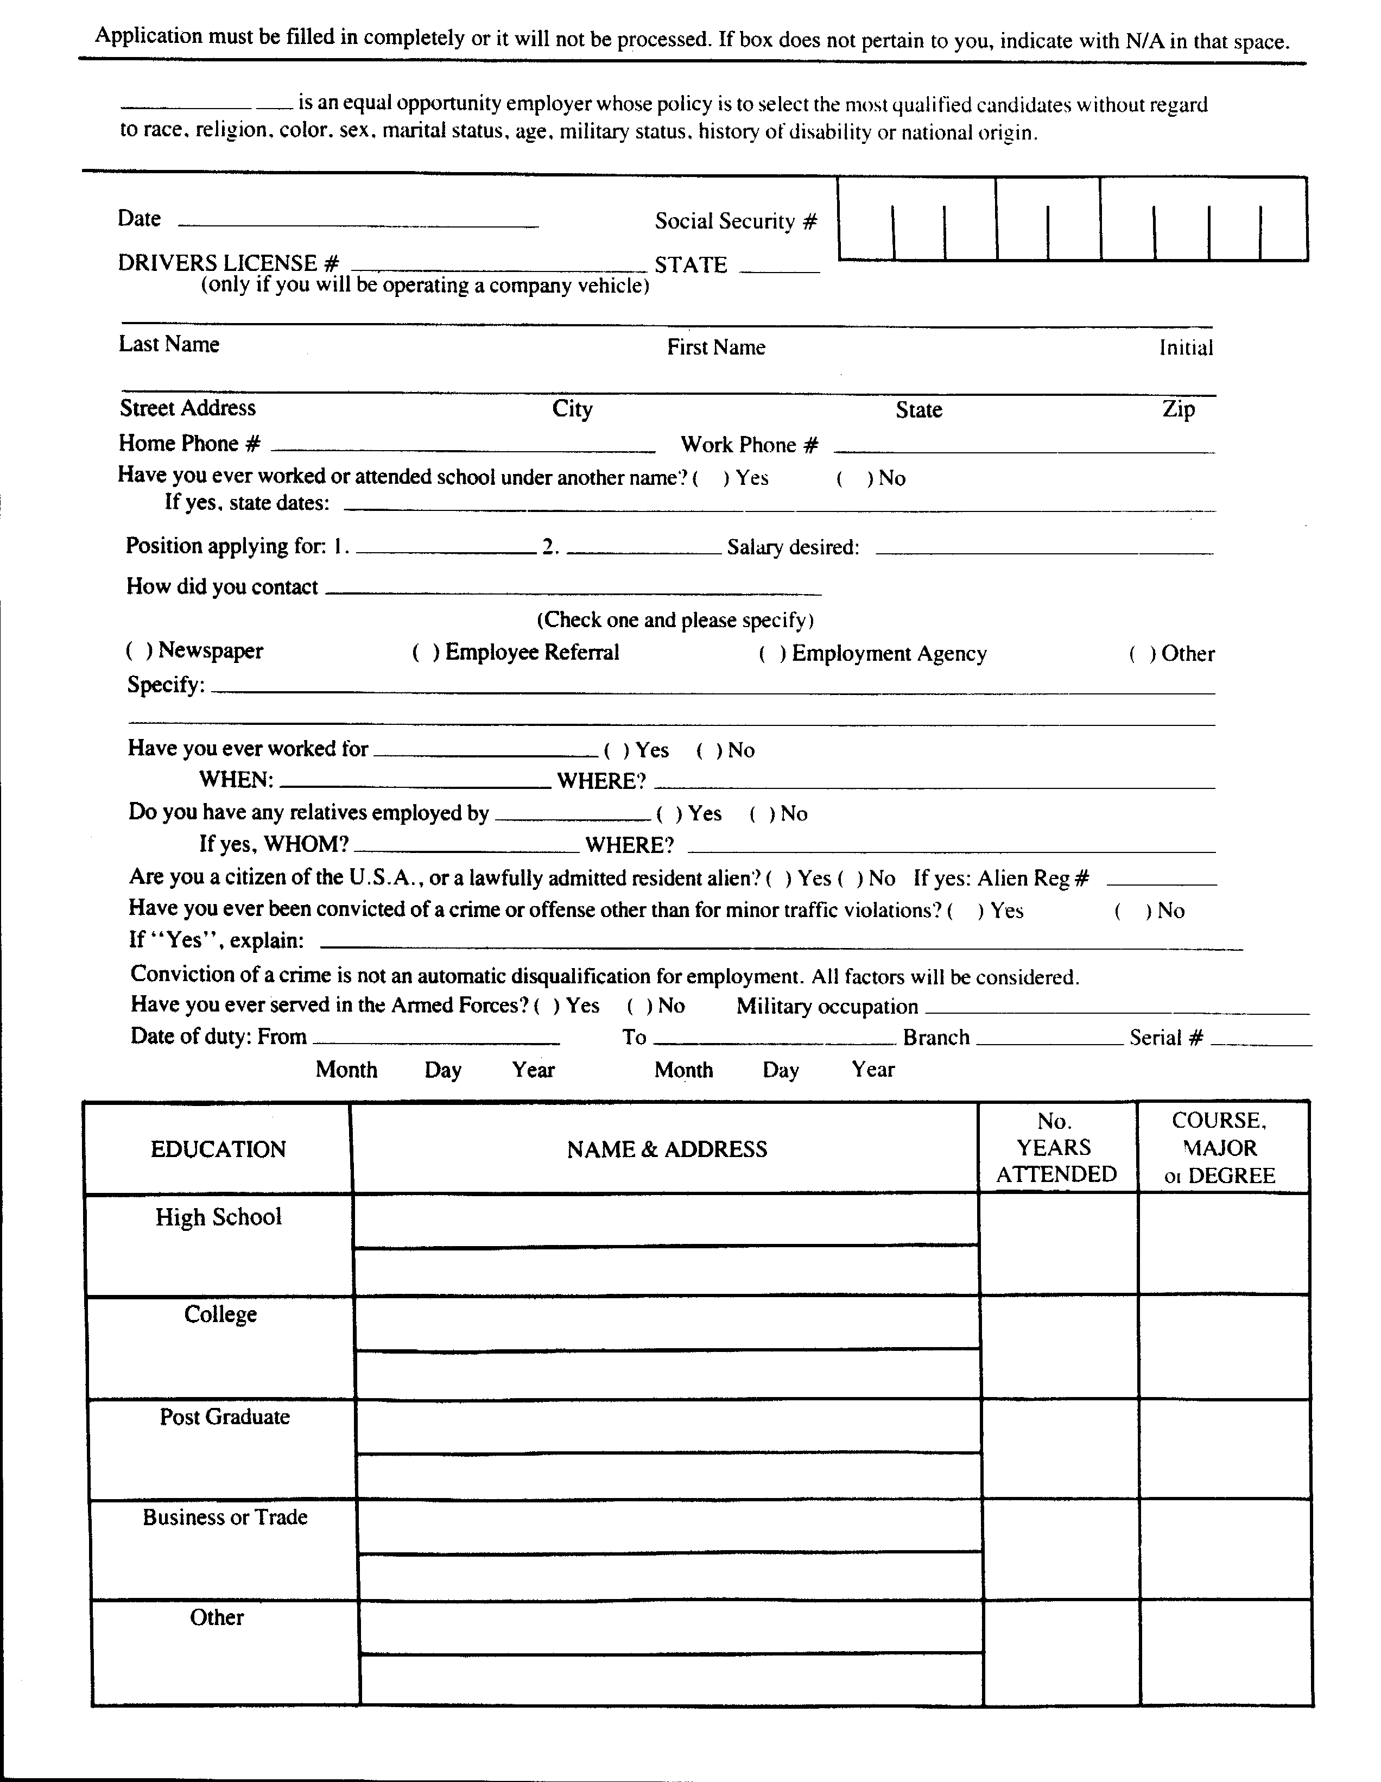
Application must be filled in completely or it will not be processed. If a box does not pertain to you, indicate with N/A in that space.

___________________________ is an equal opportunity employer whose policy is to select the most qualified candidates without regard to race, religion, color, sex, age, marital or military status, history of disability or national origin.

Date___________________________ Social Security #

Drivers License #_________________________________ State______
(only if you will be operating a company vehicle)

Last NameFirst Name Initial

Street AddressCityStateZip
Home Phone #___________________________________Work Phone #__________________________________________
Have you ever worked or attended school under another name? ( ) yes( ) no
If yes, state dates: _____________________________________________________________________________________
Position applying for: 1._______________________ 2. _______________________ Salary desired _______________________
How did you contact _______________________________________
( ) Newspaper ( ) Employee Referral( ) Employment Agency ( ) Other
Please specify: ____________________________________________________________________________________________
________________________________________________________________________________________________________
Have you ever worked for ______________________________ ( ) yes ( ) no
When? ___________________Where? ___________________________________________________________________
Do you have any relatives employed by ___________________ ( ) yes ( ) no
If yes, Name:_____________________________________________Where? ____________________________________
Are you a citizen of the USA. or a lawfully admitted resident alien? ( ) yes ( ) no If yes, Alien Reg. # ____________________
Have you ever been convicted of a crime or offense other than for minor traffic violations? ( ) yes ( ) no
If “Yes,” explain __________________________________________________________________________________________
Conviction of a crime is not an automatic disqualification for employment. All factors will be considered.
Have you ever served in the Armed Forces? ( ) yes ( ) noMilitary occupation ____________________________________
Date of duty, from _______________ to ________________ Branch ____________ Serial # _____________________________
Month Day Year Month Day Year

Application must be filled in completely or it will not be processed. If a box does not pertain to you, indicate with N/A in that space.

___________________________ is an equal opportunity employer whose policy is to select the most qualified candidates without regard to race, religion, color, sex, age, marital or military status, history of disability or national origin.

Date___________________________ Social Security #

Drivers License #_________________________________ State______
(only if you will be operating a company vehicle)

Last NameFirst Name Initial

Street AddressCityStateZip
Home Phone #___________________________________Work Phone #__________________________________________
Have you ever worked or attended school under another name? ( ) yes( ) no
If yes, state dates: _____________________________________________________________________________________
Position applying for: 1._______________________ 2. _______________________ Salary desired _______________________
How did you contact _______________________________________
( ) Newspaper ( ) Employee Referral( ) Employment Agency ( ) Other
Please specify: ____________________________________________________________________________________________
________________________________________________________________________________________________________
Have you ever worked for ______________________________ ( ) yes ( ) no
When? ___________________Where? ___________________________________________________________________
Do you have any relatives employed by ___________________ ( ) yes ( ) no
If yes, Name:_____________________________________________Where? ____________________________________
Are you a citizen of the USA. or a lawfully admitted resident alien? ( ) yes ( ) no If yes, Alien Reg. # ____________________
Have you ever been convicted of a crime or offense other than for minor traffic violations? ( ) yes ( ) no
If “Yes,” explain __________________________________________________________________________________________
Conviction of a crime is not an automatic disqualification for employment. All factors will be considered.
Have you ever served in the Armed Forces? ( ) yes ( ) noMilitary occupation ____________________________________
Date of duty, from _______________ to ________________ Branch ____________ Serial # _____________________________
Month Day Year Month Day Year

Basic Application (page 2)
Other experience(s) skills you would like to mention: ________________________________________________
_________________________________________________________________________________________
_________________________________________________________________________________________
_________________________________________________________________________________________

At least (2) two Personal References:
Name: ___________________________________________________Phone #: __________________
Address:__________________________________________________Years Known:______________
Name: ___________________________________________________Phone #: __________________
Address: _________________________________________________Years Known: _____________

I n case of emergency notify: _________________________________________________________________
Phone numbers: ___________________________________________________________________________
Address: _________________________________________________________________________________
Relationship: _____________________________________________________________________________

Print Name: _____________________________________________S.S. #_____________________

I AGREE AND UNDERSTAND THAT ALL THE STATEMENTS AND INFORMATION ON MY APPLICATION ARE CORRECT AND NO ATTEMPT HAS BEEN MADE TO CONCEAL OR WITHHOLD PERTINENT INFORMATION. I AGREE THAT ANY OMISSION, FALSIFICATION, OR MISREPRESENTATION IS CAUSE FOR IMMEDIATE TERMINATION AT ANY TIME DURING MY EMPLOYMENT.

I HEREBY AUTHORIZE INVESTIGATION OF ALL STATEMENTS AT THIS TIME WITH NO LIABILITY ARISING THEREFROM _________________________.

I WILL ABIDE BY ALL RULES, REGULATIONS AND POLICIES OF ________________________.

AT THE OPTION OF THE COMPANY, I AGREE TO PHYSICAL EXAMINATION BY A PHYSICIAN CHOSEN BY ___________________________________ WITH THE UNDERSTANDING THAT MY EMPLOYMENT AT ___________________________________ DEPENDS UPON MY PASSING THE PHYSICAL.

I UNDERSTAND THAT A 90 WORKING PROBATIONARY PERIOD WILL BE IN EFFECT IN THE EVENT EMPLOYMENT IS OFFERED.

DATE _________________SIGNATURE _________________________________

Basic Application (page 3)
Other experience(s) skills you would like to mention: ______________________________________
__________________________________________________________________________________
__________________________________________________________________________________
__________________________________________________________________________________

At least (2) two Personal References:
Name: _______________________________________Phone #: __________________________
Address: _____________________________________Years Known: _____________________

Name: _______________________________________Phone #: __________________________
Address: _____________________________________Years Known: _____________________

I n cases of emergency notify: _________________________________________________________
Phone numbers: ____________________________________________________________________
Address: __________________________________________________________________________
Relationship:_______________________________________________________________________

Print Name: ___________________________________S.S. #: ____________________________

I AGREE AND UNDERSTAND THAT ALL THE STATEMENTS AND INFORMATION ON MY APPLICATION ARE CORRECT AND NO ATTEMPT HAS BEEN MADE TO CONCEAL OR WITHHOLD PERTINENT INFORMATION. I AGREE THAT ANY OMISSION, FALSIFICATION, OR MISREPRESENTATION IS CAUSE FOR IMMEDIATE TERMINATION AT ANY TIME DURING MY EMPLOYMENT.

I HEREBY AUTHORIZE INVESTIGATION OF ALL STATEMENTS AT THIS TIME WITH NO LIABILITY ARISING THEREFROM _________________________.

I WILL ABIDE BY ALL RULES, REGULATIONS AND POLICIES OF ______________________
_________________________________________________________________________________.

AT THE OPTION OF THE COMPANY, I AGREE TO PHYSICAL EXAMINATION BY A PHYSICIAN CHOSEN BY ___________________________________ WITH THE UNDERSTANDING THAT MY EMPLOYMENT AT ___________________________________ DEPENDS UPON MY PASSING THE PHYSICAL.

I UNDERSTAND THAT A 90 WORKING PROBATIONARY PERIOD WILL BE IN EFFECT IN THE EVENT EMPLOYMENT IS OFFERED.

DATE _________________SIGNATURE ______________________________________

Confidentiality Agreement
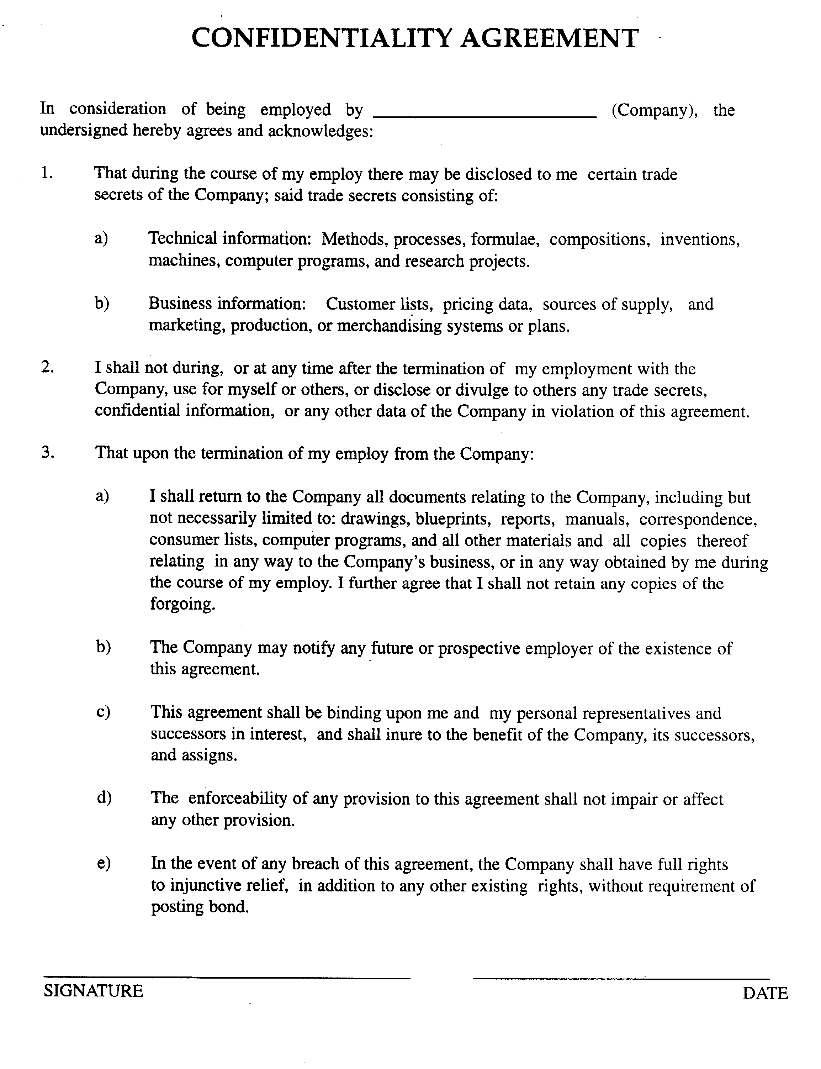

Criminal Background Check Release

Criminal Background Check
R e l e a s e F o r m

NAME__________________________________________________________________________
Last First Middle Maiden

ADDRESS_______________________________________________________________________
Street City State

ALIASES OR OTHER NAMES USED _______________________________________________

DATE OF BIRTH _________________ AGE ____ RACE ____________________ SEX ____

SOCIAL SECURITY # ________________________________

DRIVER’S LICENSE # ______________________________ STATE _____________________

* * *

I hereby authorize _________________________ of _____________________________________
Name Name of Company

_______________________________________________________________________________
Company Address/City/State/Zip

to conduct a criminal background check on myself through the

_______________________________________________________________________________ .
Name of State and Police Agency

X_______________________________________
Applicant Signature

* * *

STATE of:_________________ This Instrument was acknowledged before me this ____ day of
COUNTY of:_______________ ____________________, 20 _____, by ___________________
My commission will expire: _______________________________________AS WITNESS.
__________________________
___________________________________________________
Notary Public No.

Employee Data Sheet

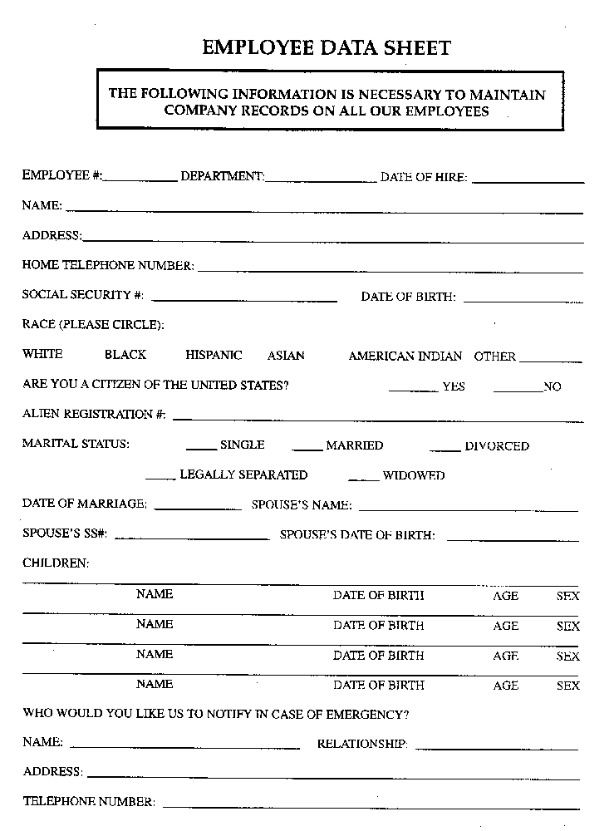

Employment Eligibility Verification (I-9)
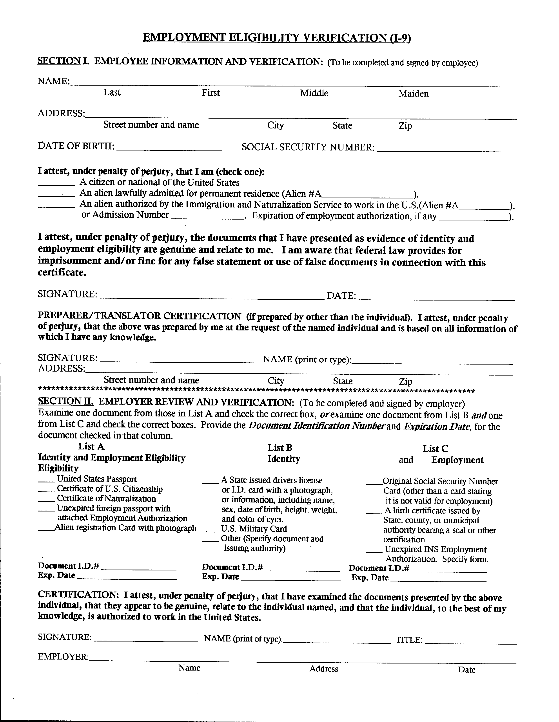

Exit Interview Report (page 1)
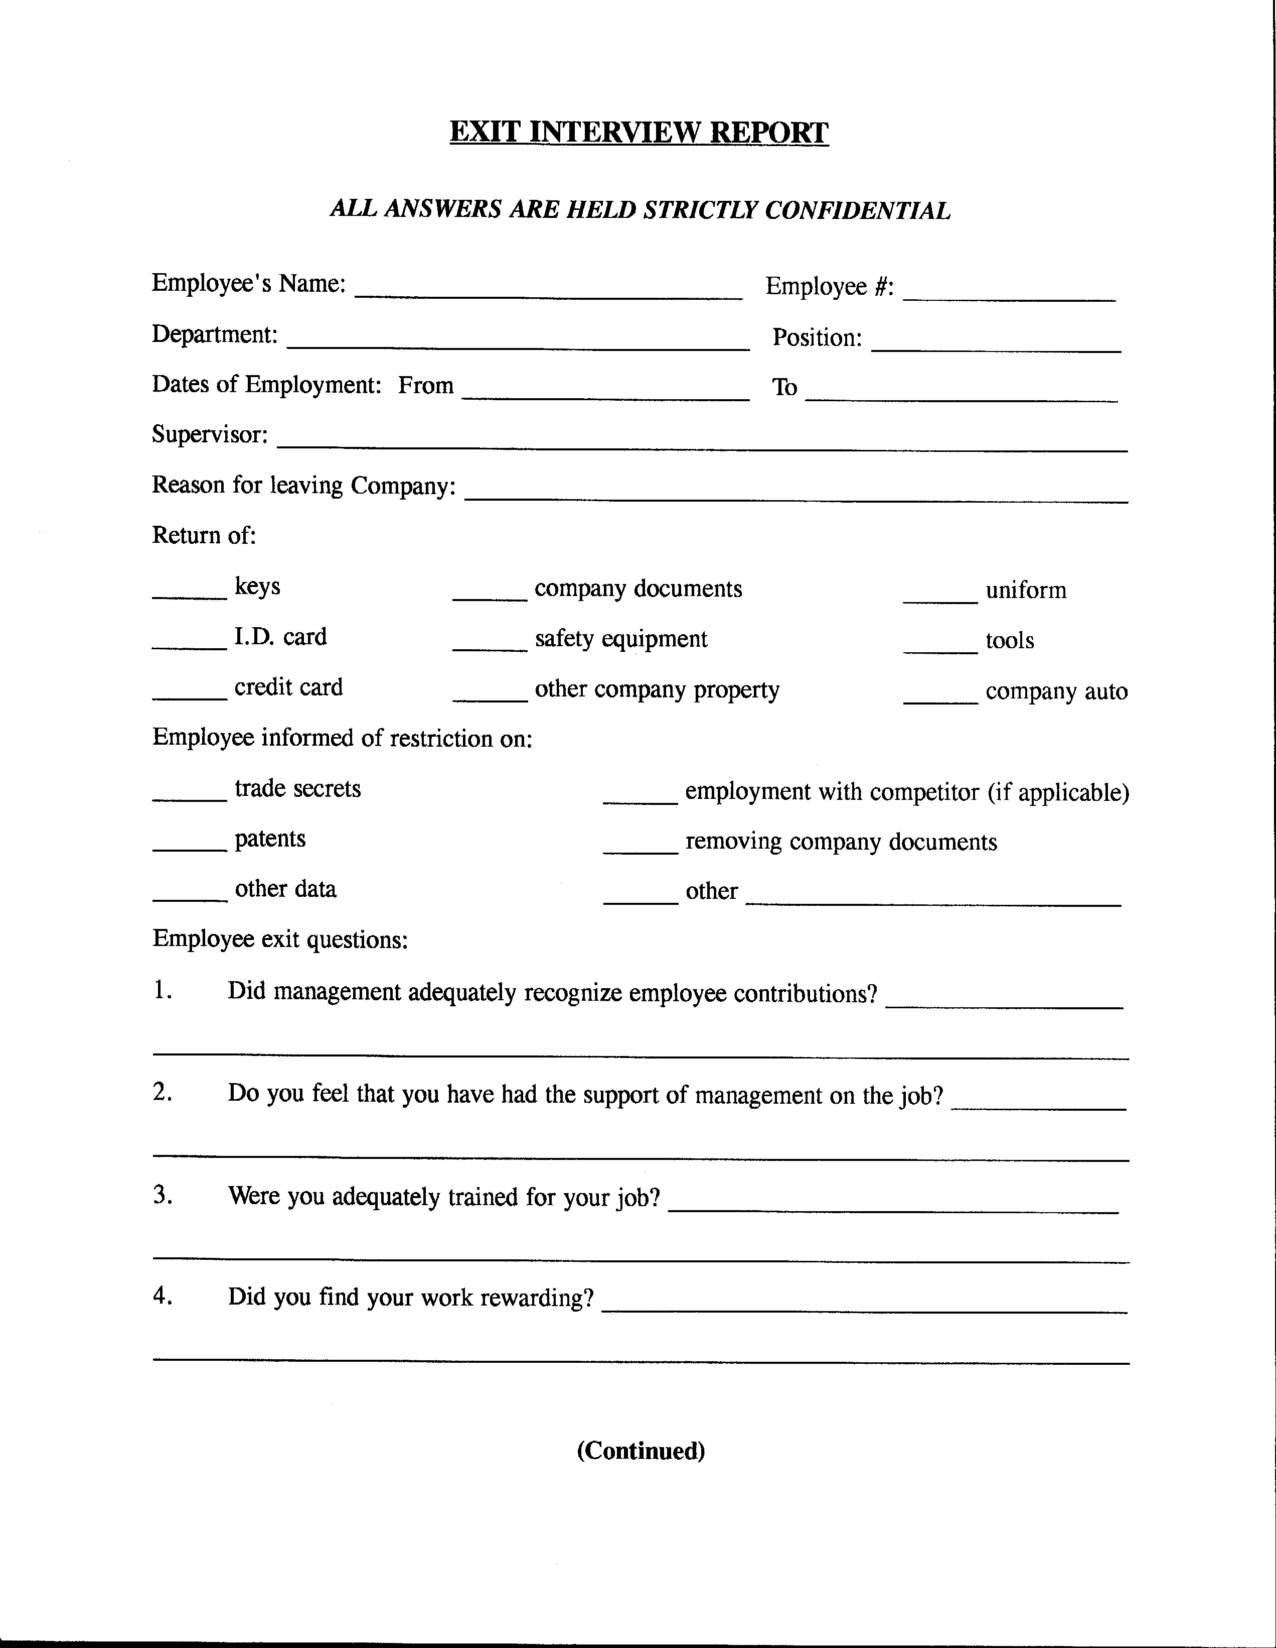

Exit Interview Report (page 2)
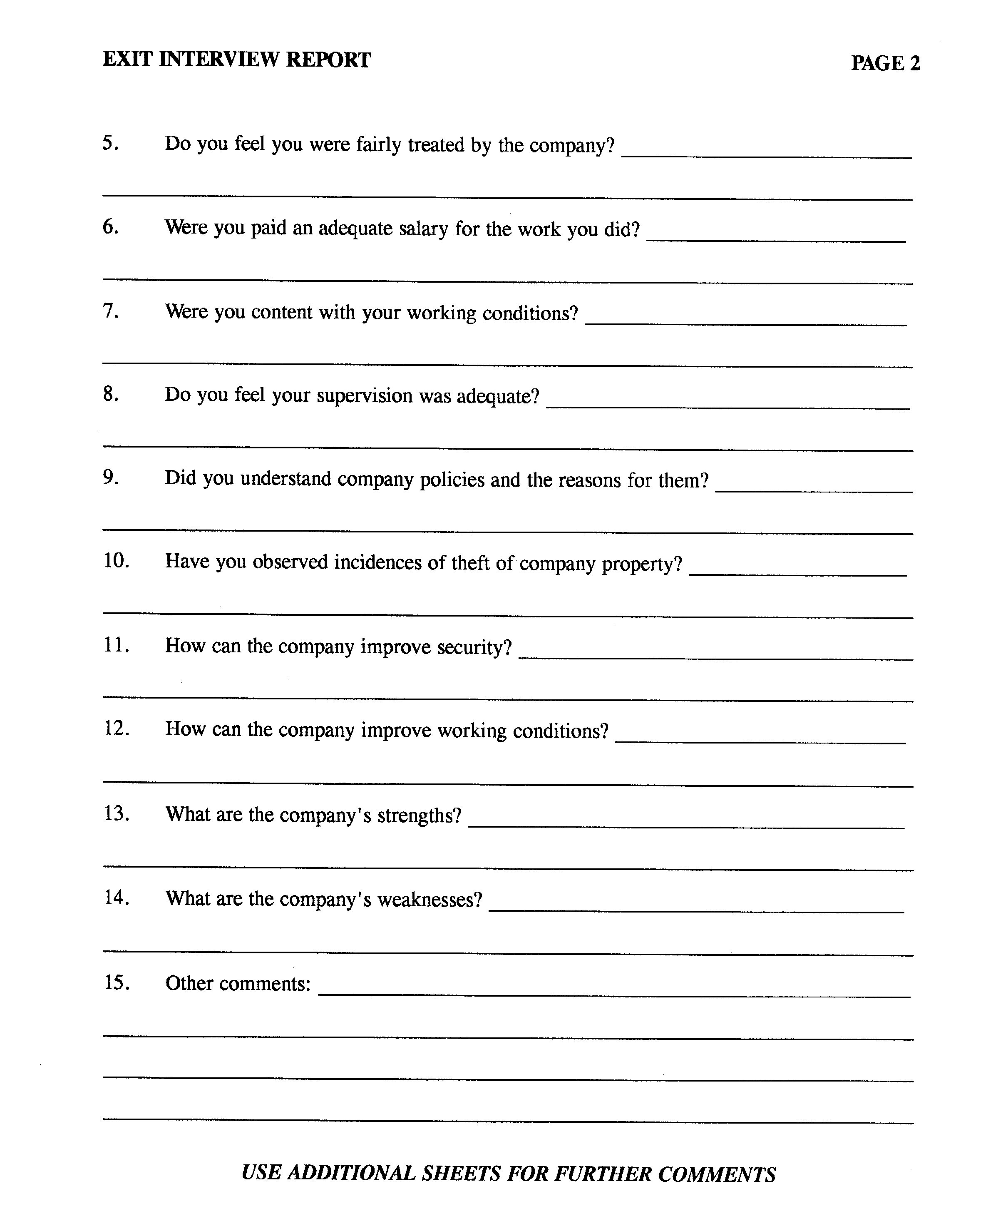

General Release Form
General Release Form

In connection with my application for employment (including contract for service) with you, I understand that investigative inquiries are to be made on myself including consumer credit, criminal convictions, motor vehicle, and other reports. These reports will include information as to my character, work, habits, performance and experience along with reasons for termination of past employment from previous employers. Further, I understand that you will be requesting information from various Federal, State, and other agencies that maintain records concerning my past activities relating to my driving, credit, criminal, civil, education, and other experiences.

I authorize without reservation any party or agency contacted by this employer to furnish the above-mentioned information.

I hereby consent to your obtaining the above information from ___________________
_____________________ and/or any of their licensed agents. I understand to aid in the proper identification of my file or records, the following personal identifiers, as well as other information, is necessary.

Print Name ____________________________________________________________

Social Security Number ______-____-_______

Date of Birth ________________________ Sex ________ Race __________________

Current Address ________________________________________________________

City/State/Zip Code+4 ___________________________________________________

Former Address ________________________________________________________

Applicant Signature _________________________________ Date _______________

Prospective Employer ___________________________________________________

Induction Form
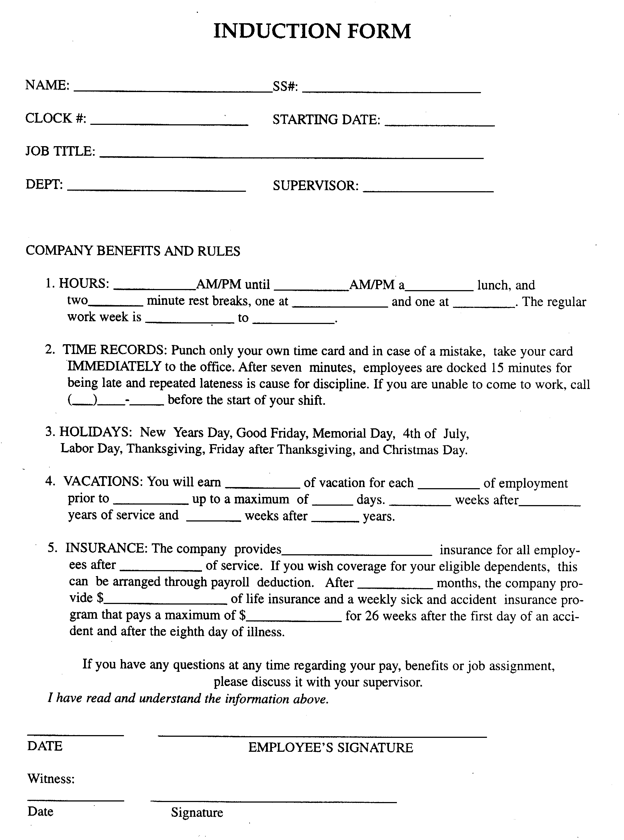

Local Police Information Request
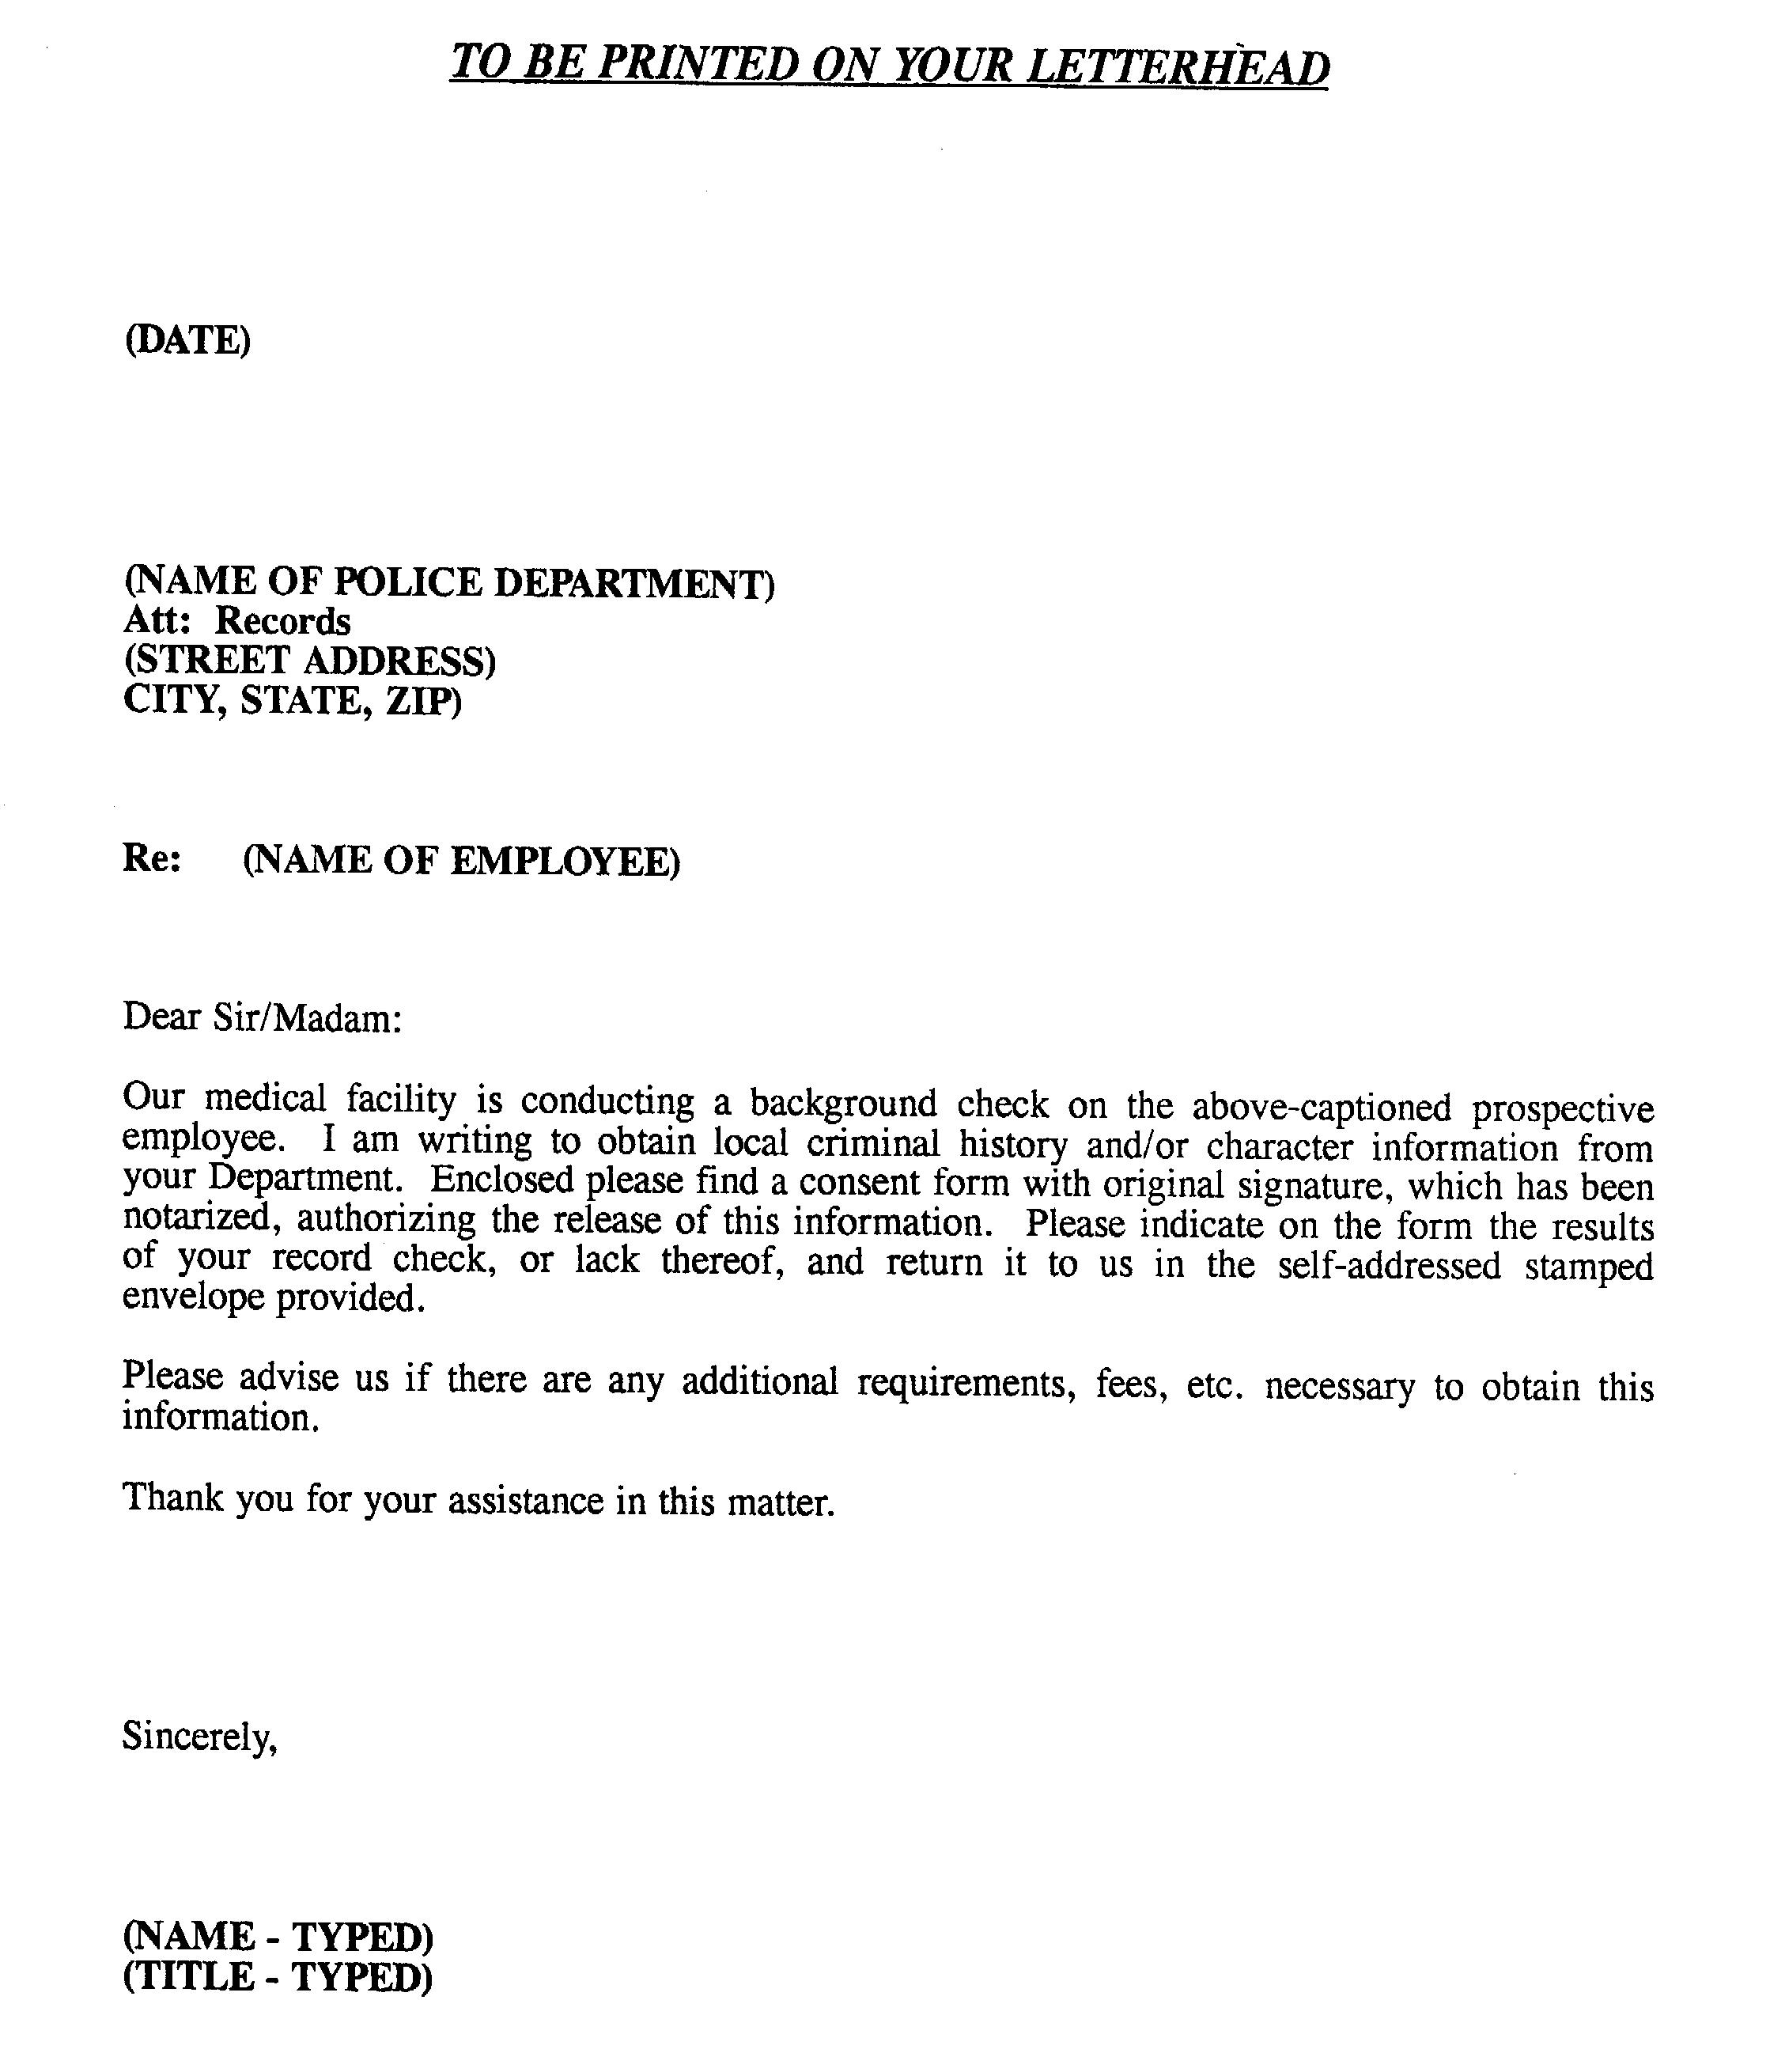

Military Records Request (front)
Also available online at: www.nara.gov/regional/mprsf180.html.
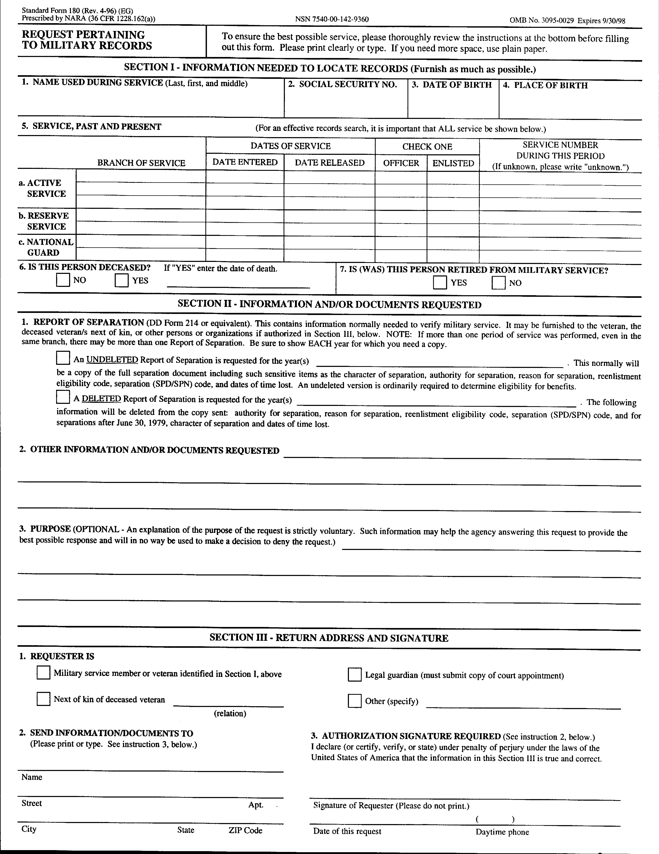

Military Records Request (reverse)
Also available online at: www.nara.gov/regional/mprsf180.html.

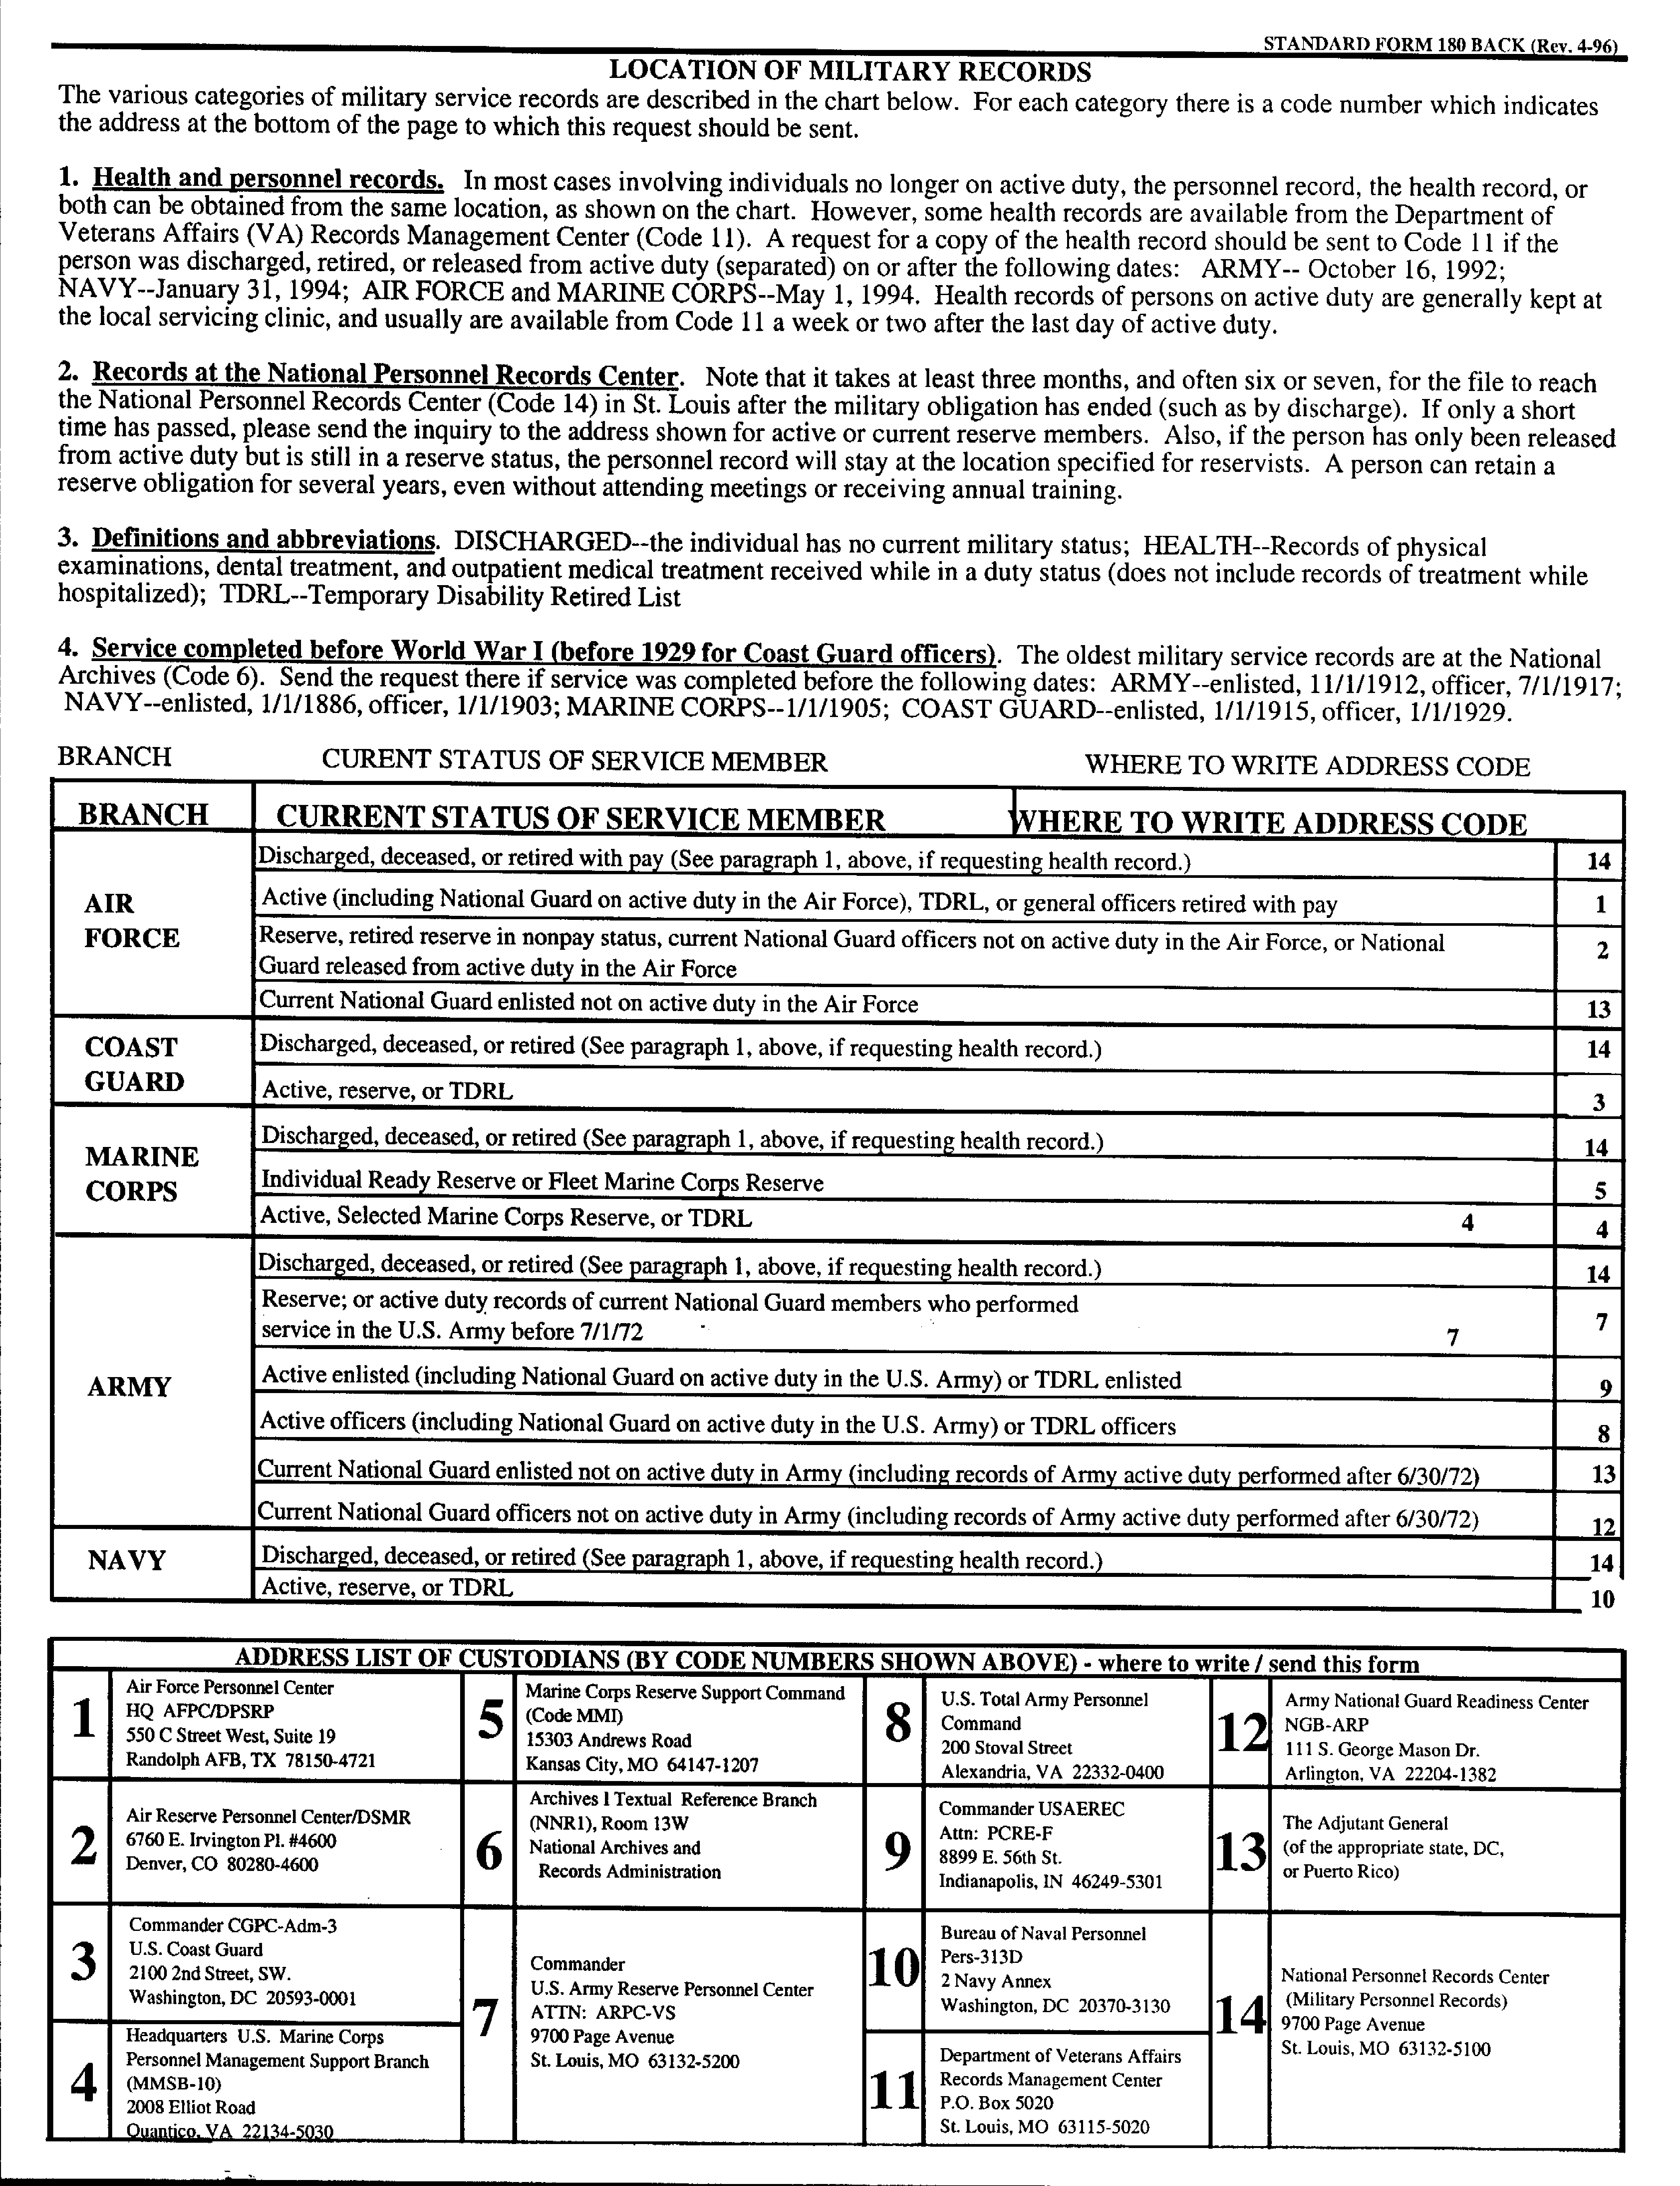

New Employee Record Chart
New Employee Record Chart

Employee ________________________Position _____________________

Department _______________________Date Employed _______________

The above new employee must have checked item(s) in file.

DocumentRequiredCompleted

Employment Application_________________
Employee Data Sheet_________________
W-4 _________________
I-9_________________
Induction Form_________________
New Hire Report_________________
Applicant Waiver Releases_________________
Substance Abuse Test Consent_________________
Non-Compete Agreement_________________
Confidentiality Agreement_________________
________________________________________________________________________
________________________________________________________________________

_____________________________
Supervisor
_____________________________
Date

New Hire Reporting
New Hire Reporting Form

Send Completed Form to: ________________________________Fax form to: ______________
Agency fax ________________________________ or ______________

________________________________For info, call: ______________
Name & Address of New Hire State Contact Agency phone

— EMPLOYER INFORMATION —

Federal Employer
Identification Number_________________________________________________________

Employer Name _________________________________________________________

Address_________________________________________________________
(Please indicate the address where Income Withholding Order will be sent)

City/State/Zip+4_________________________________________________________

— EMPLOYEE INFORMATION —

Social Security Number______ - ____ - _______

Employee Name_________________________________________________________

Employee Address_________________________________________________________

City/State/Zip Code+4_________________________________________________________

— EMPLOYEE INFORMATION —

Social Security Number______ - ____ - _______

Employee Name_________________________________________________________

Employee Address_________________________________________________________

City/State/Zip Code+4_________________________________________________________

Non-Compete Agreement

General Non-Compete Agreement

For good consideration and as an inducement for _____________________ (Company), to employ ________________________ (Employee), the undersigned employee hereby agrees not to directly or indirectly compete with the business of the Company during the period of ___________ years following termination of employment and notwithstanding the cause of reason for termination.

The term "not to compete" as used herein shall mean that the Employee shall not own, operate, consult to, or be employed by any firm in a business substantially similar to or competitive with the present business of the Company or such business activity in which the Company may engage during the term of employment.

The Employee acknowledges that the Company shall or may in reliance of this agreement provide Employee access to trade secrets, customers, and other confidential data and that the provisions of this agreement are reasonably necessary to protect the Company.

This agreement shall be binding upon and inure to the benefit of the parties, their successors, assigns, and personal representatives.

Signed under seal this ______________ day of ________________, 20______.

__________________________________________
Company

__________________________________________
Employee

Performance Review (page 1)

Performance Review

_________________________________________ _________________________________
Employee Name Reviewer Name

_________________________________________ _________________________________
Job Title Date of Review

Circle One Reviewer Notes
Availability Excellent _________________________________
Punctuality/Absence Satisfactory _________________________________
Time Awareness Needs Improvement _________________________________

Job Awareness Excellent _________________________________
Accountabilities Satisfactory _________________________________
Sets Goals Needs Improvement _________________________________

Behavior Excellent _________________________________
Interaction w/ others Satisfactory _________________________________
Manners/Neatness Needs Improvement _________________________________

Complies w/ Policy Excellent _________________________________
Follows Procedures Satisfactory _________________________________
Safety Rules Needs Improvement _________________________________

Dependability Excellent _________________________________
Performs assignments Satisfactory _________________________________
Needs Improvement _________________________________

Initiative Excellent _________________________________
Develops Solutions Satisfactory _________________________________
Provides Ideas Needs Improvement _________________________________

Independence Excellent _________________________________
Tracks Assignments Satisfactory _________________________________
Needs Supervision Needs Improvement _________________________________

Productivity Excellent _________________________________
Quality / Accuracy Satisfactory _________________________________
Corrects Errors Needs Improvement _________________________________

Continued

Performance Review (page 2)

Performance Review – Page 2
__________________________________

Employee Name

New and/or noteworthy accomplishments since last evaluation
_____________________________________________________________________
_____________________________________________________________________
_____________________________________________________________________
_____________________________________________________________________

Areas in need of improvement
_____________________________________________________________________
_____________________________________________________________________
_____________________________________________________________________
_____________________________________________________________________

Recommendations
_____________________________________________________________________
_____________________________________________________________________
_____________________________________________________________________
_____________________________________________________________________

Overall Performance Summary: Excellent

(Circle one) Satisfactory

Needs Improvement
________________________________________________________________________

Employee Comments
_____________________________________________________________________
_____________________________________________________________________
_____________________________________________________________________
_____________________________________________________________________

_____________________________ ______________________________
Employee Signature Reviewer Signature

_____________________________ ______________________________
Date Date of Next Review

Pre-Employment Check by Phone
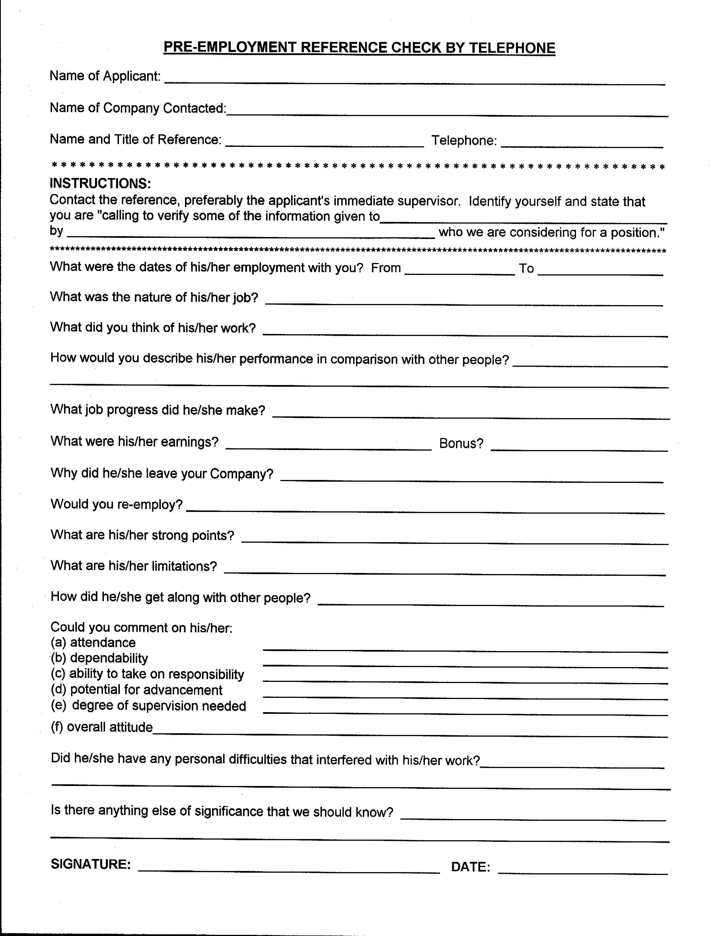

Rejection Letter Sample

(To be produced on your company letterhead)

(Insert date)

Dear (insert name):

Thank you for your interest in working for our organization. Many talented and qualified people applied for this position, including you. After much consideration, we have hired another applicant.

Thank you for your time, and good luck in your job search.

Sincerely,

(Insert your signature and name here)

Request For Education Verification

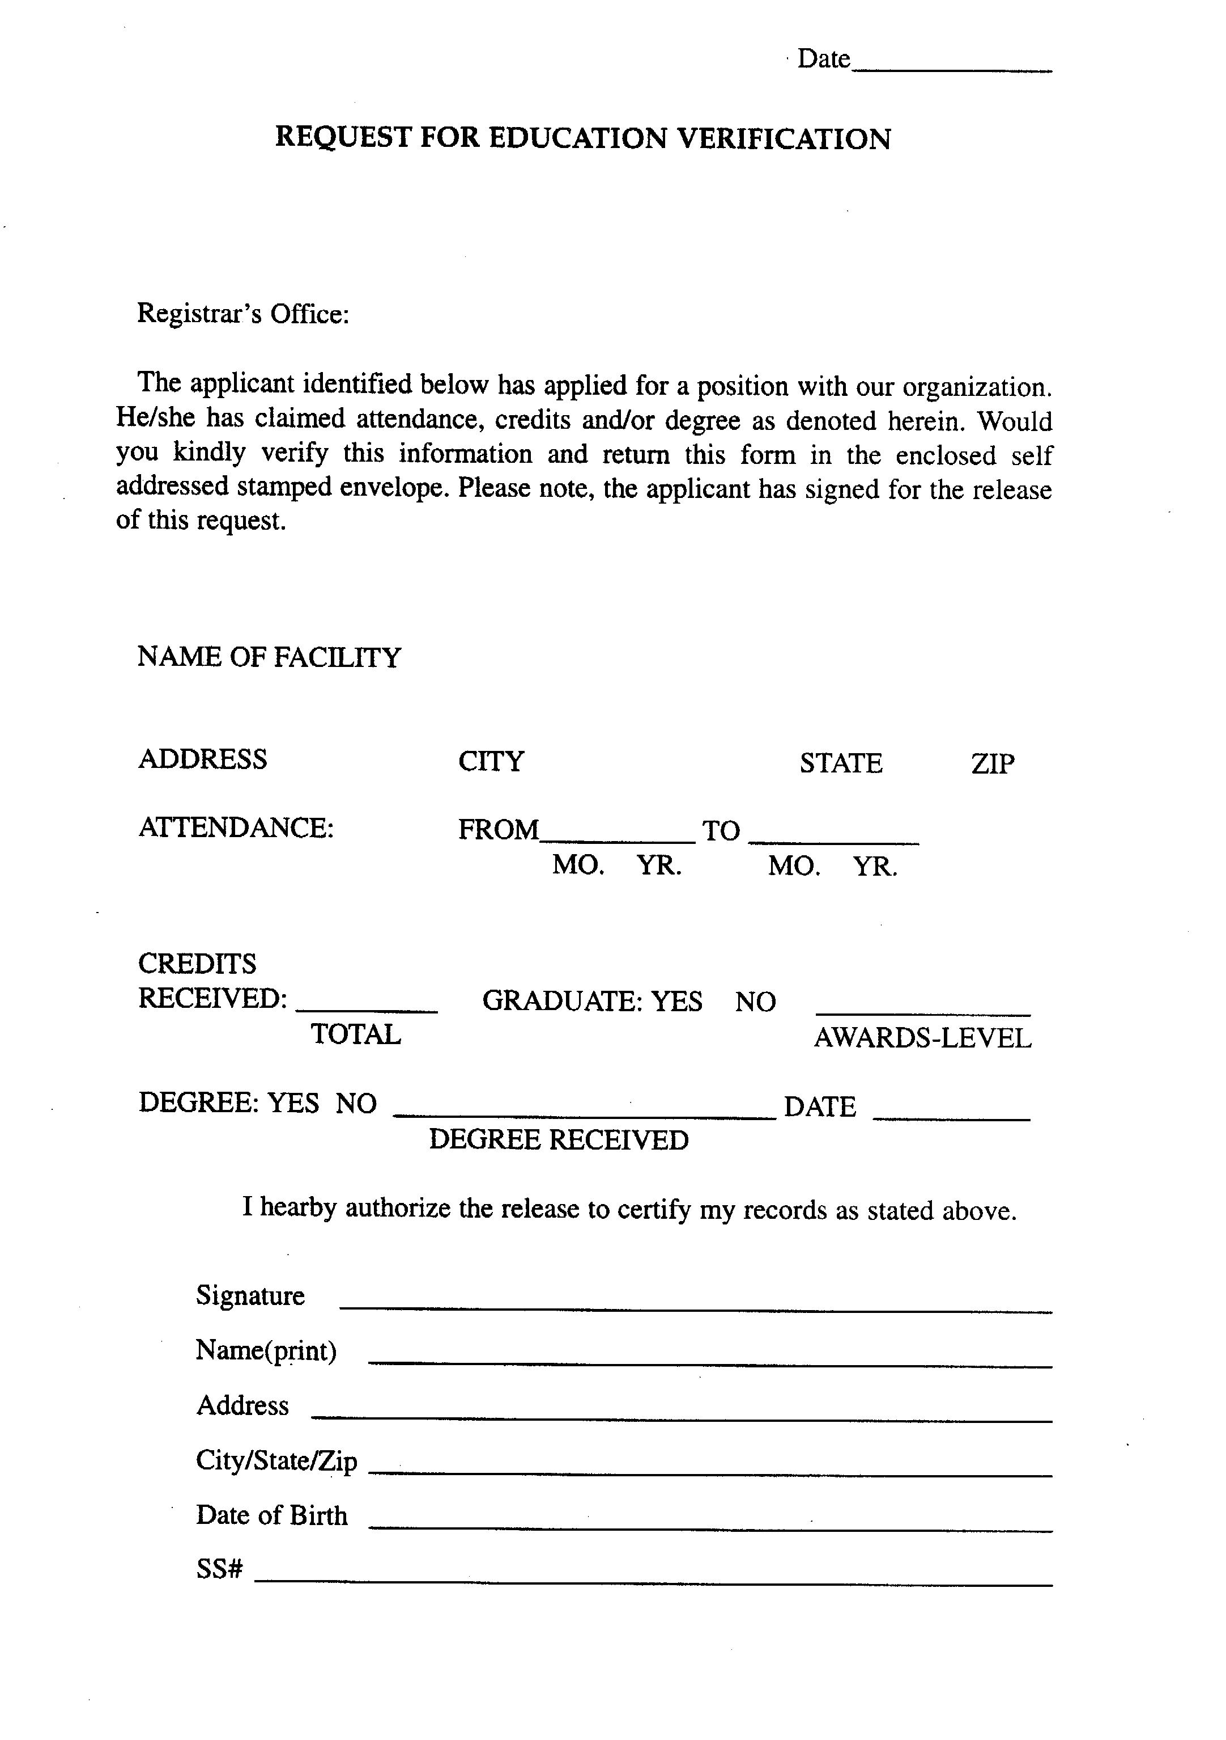

Request For Information
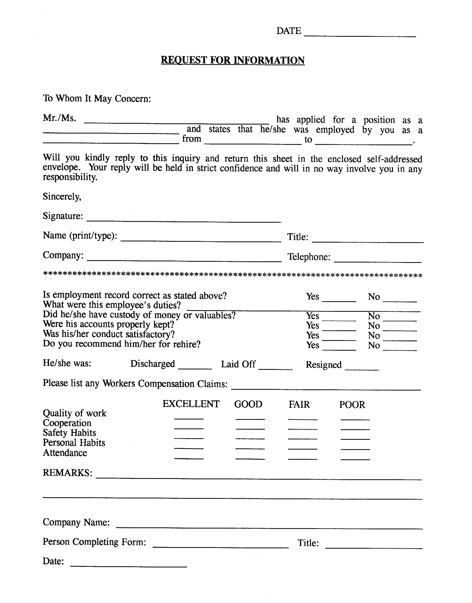

Substance Abuse Screening Test – Applicant Consent
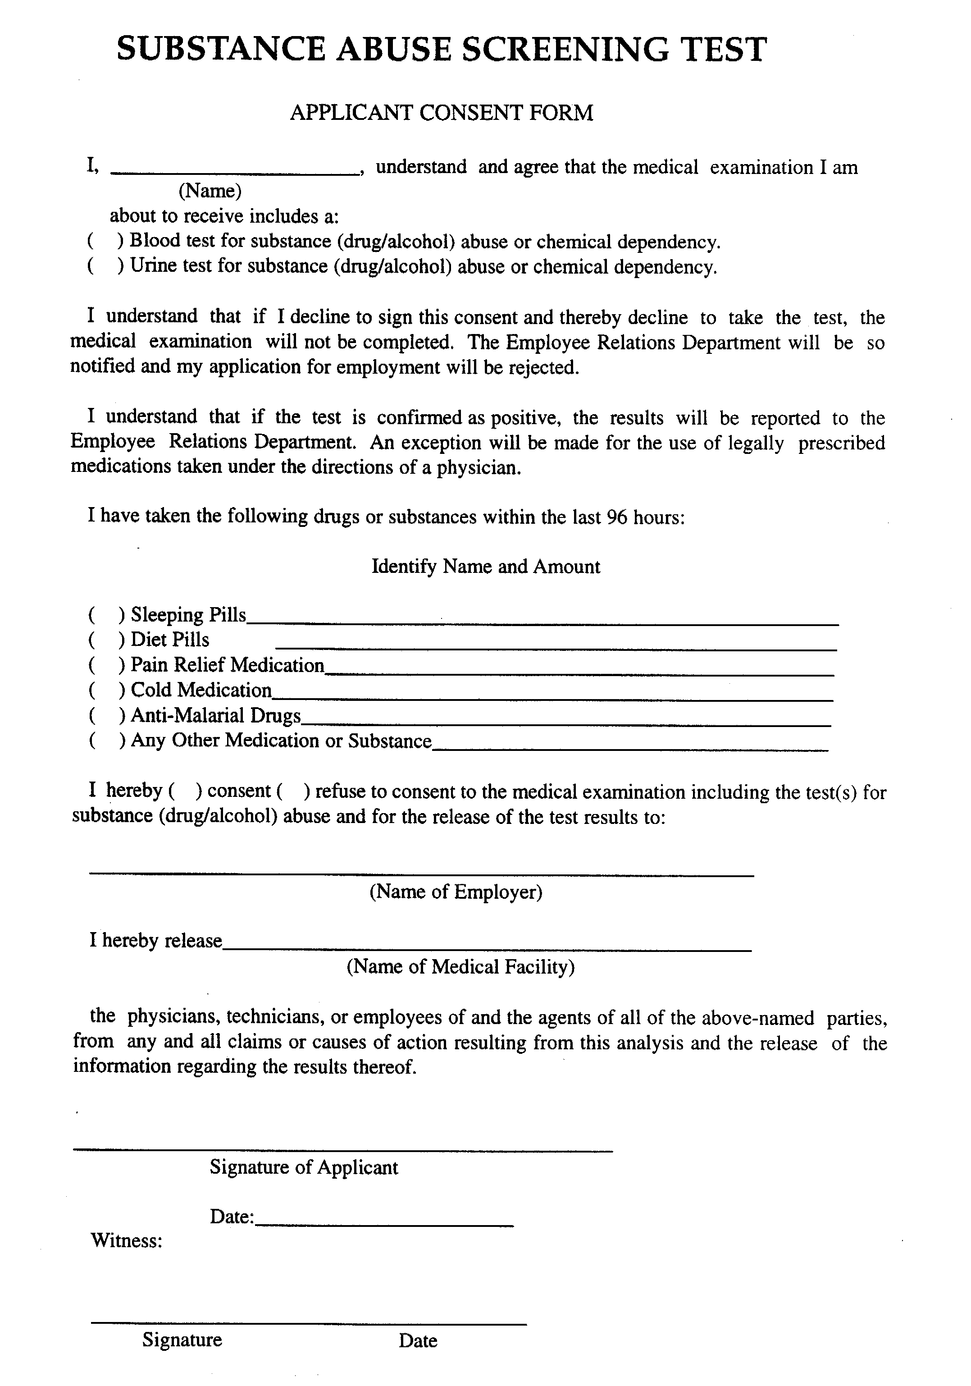

Workers’ Compensation Release Form
Workers’ Compensation Release Form

From: Employer__________________________ Re:Employee ______________________________
Address__________________________Address ______________________________
__________________________Social Security # ________________________

- - - EMPLOYEE AUTHORIZATION - - -

I, _________________________________________________, do hereby authorize certify that I received an offer
Employee Name
of employment from ____________________________________________________________________________
Employer Name and Address
on _____________________________ and authorize the ______________________________________________
Date Name of State & Workers’ Compensation Agency
_____________________________ to release all information from Bureau files.

I affirm the information I have provided herein is true. I understand that if I make any false statements which I do not believe to be true and thereby mislead the public servant to whom this request is directed in performing his/her official function, I may be subject to State Criminal Codes where provided.

________________________ X_______________________________________
Date Employee Signature

- - - EMPLOYER CERTIFICATION - - -

I __________________________________________, ___________________________________, an employee of
Name Title with Employer
and acting as agent for ________________________________________________________ do hereby certify that
Employer
____________________________________________________________ has extended an offer of employment to
Employer
___________________________________________ on _______________________ and I agree that information
Employee Date
requested from the______________________________________________________________________________
State Workers’ Compensation Agency
with regard to __________________________________ will be used by _________________________________
Employee Employer
in conformance with both the Americans With Disabilities Act and ______________________________________

____________________________________________________________________________________________.
State and its Laws regarding Workers’ Compensation

I affirm the information I have provided herein is true. I understand that if I make any false statements which I do not believe to be true and thereby mislead the public servant to whom this request is directed in performing his/her official function, I may be subject to State Criminal Codes where provided.

________________________ X_______________________________________
Date Signature
_______________________________________
Title

